
Accounting and Management (AIS 211)
Management in Action
Understanding the Four Key Functions
for Business Success of Flare Studio.

Submitted to:
Md. Tariqul Islam
Associate Professor
Department of Management Studies
Faculty of Business Administration

Submitted by:
ID | Reg | Name
2102019 | 10146 | Hridoy Chandra Sarker
2102020 | 10147 | Md. Sadman Kabir Bhuiyan
2102021 | 10148 | Sadman Hafiz Shuvo
2102022 | 10149 | Noshin Nazia
2102023 | 10150 | Md. Senarul Islam
2102024 | 10151 | Md. Sharafat Karim
2102025 | 10152 | Seemanta Shill
2102026 | 10153 | Nayema Ferdoushi
Date of submission: 7 October, 2024
C O N T E N T S
Flare Studio 3
Overview 3
History 3
Preface 3
Our apps 3
Management in action 4
I) Planning 4
1. Goal Setting 4
2. Market Research and Data Analysis 5
3. Resource Allocation 5
4. Project Planning and Timeline 5
5. Design Framework for Planning 6
6. Risk Management and Contingency Planning 6
II) Organizing 7
1. Defining Roles and Responsibilities 7
2. Task Structuring and Workflows 7
3. Coordination Across Teams 8
4. Resource Allocation 8
5. Managing Multiple Projects Simultaneously 9
6. Building a Flexible and Adaptive Organizational Structure 9
7. Documenting Processes 9
III) Leading 10
1. Leadership Approach 10
3. Team Motivation & Culture 10
4. Decision-Making 11
5. Performance Management 11
6. Conflict Resolution 11
7. Leadership Impact 12
IV) Controlling 12
1. Performance Monitoring 12
2. Quality Control 12
3. Budget Control 13
4. Corrective Actions 13
5. Feedback Loops 13
6. Final Evaluation 14
Conclusion 15

Flare Studio

Overview
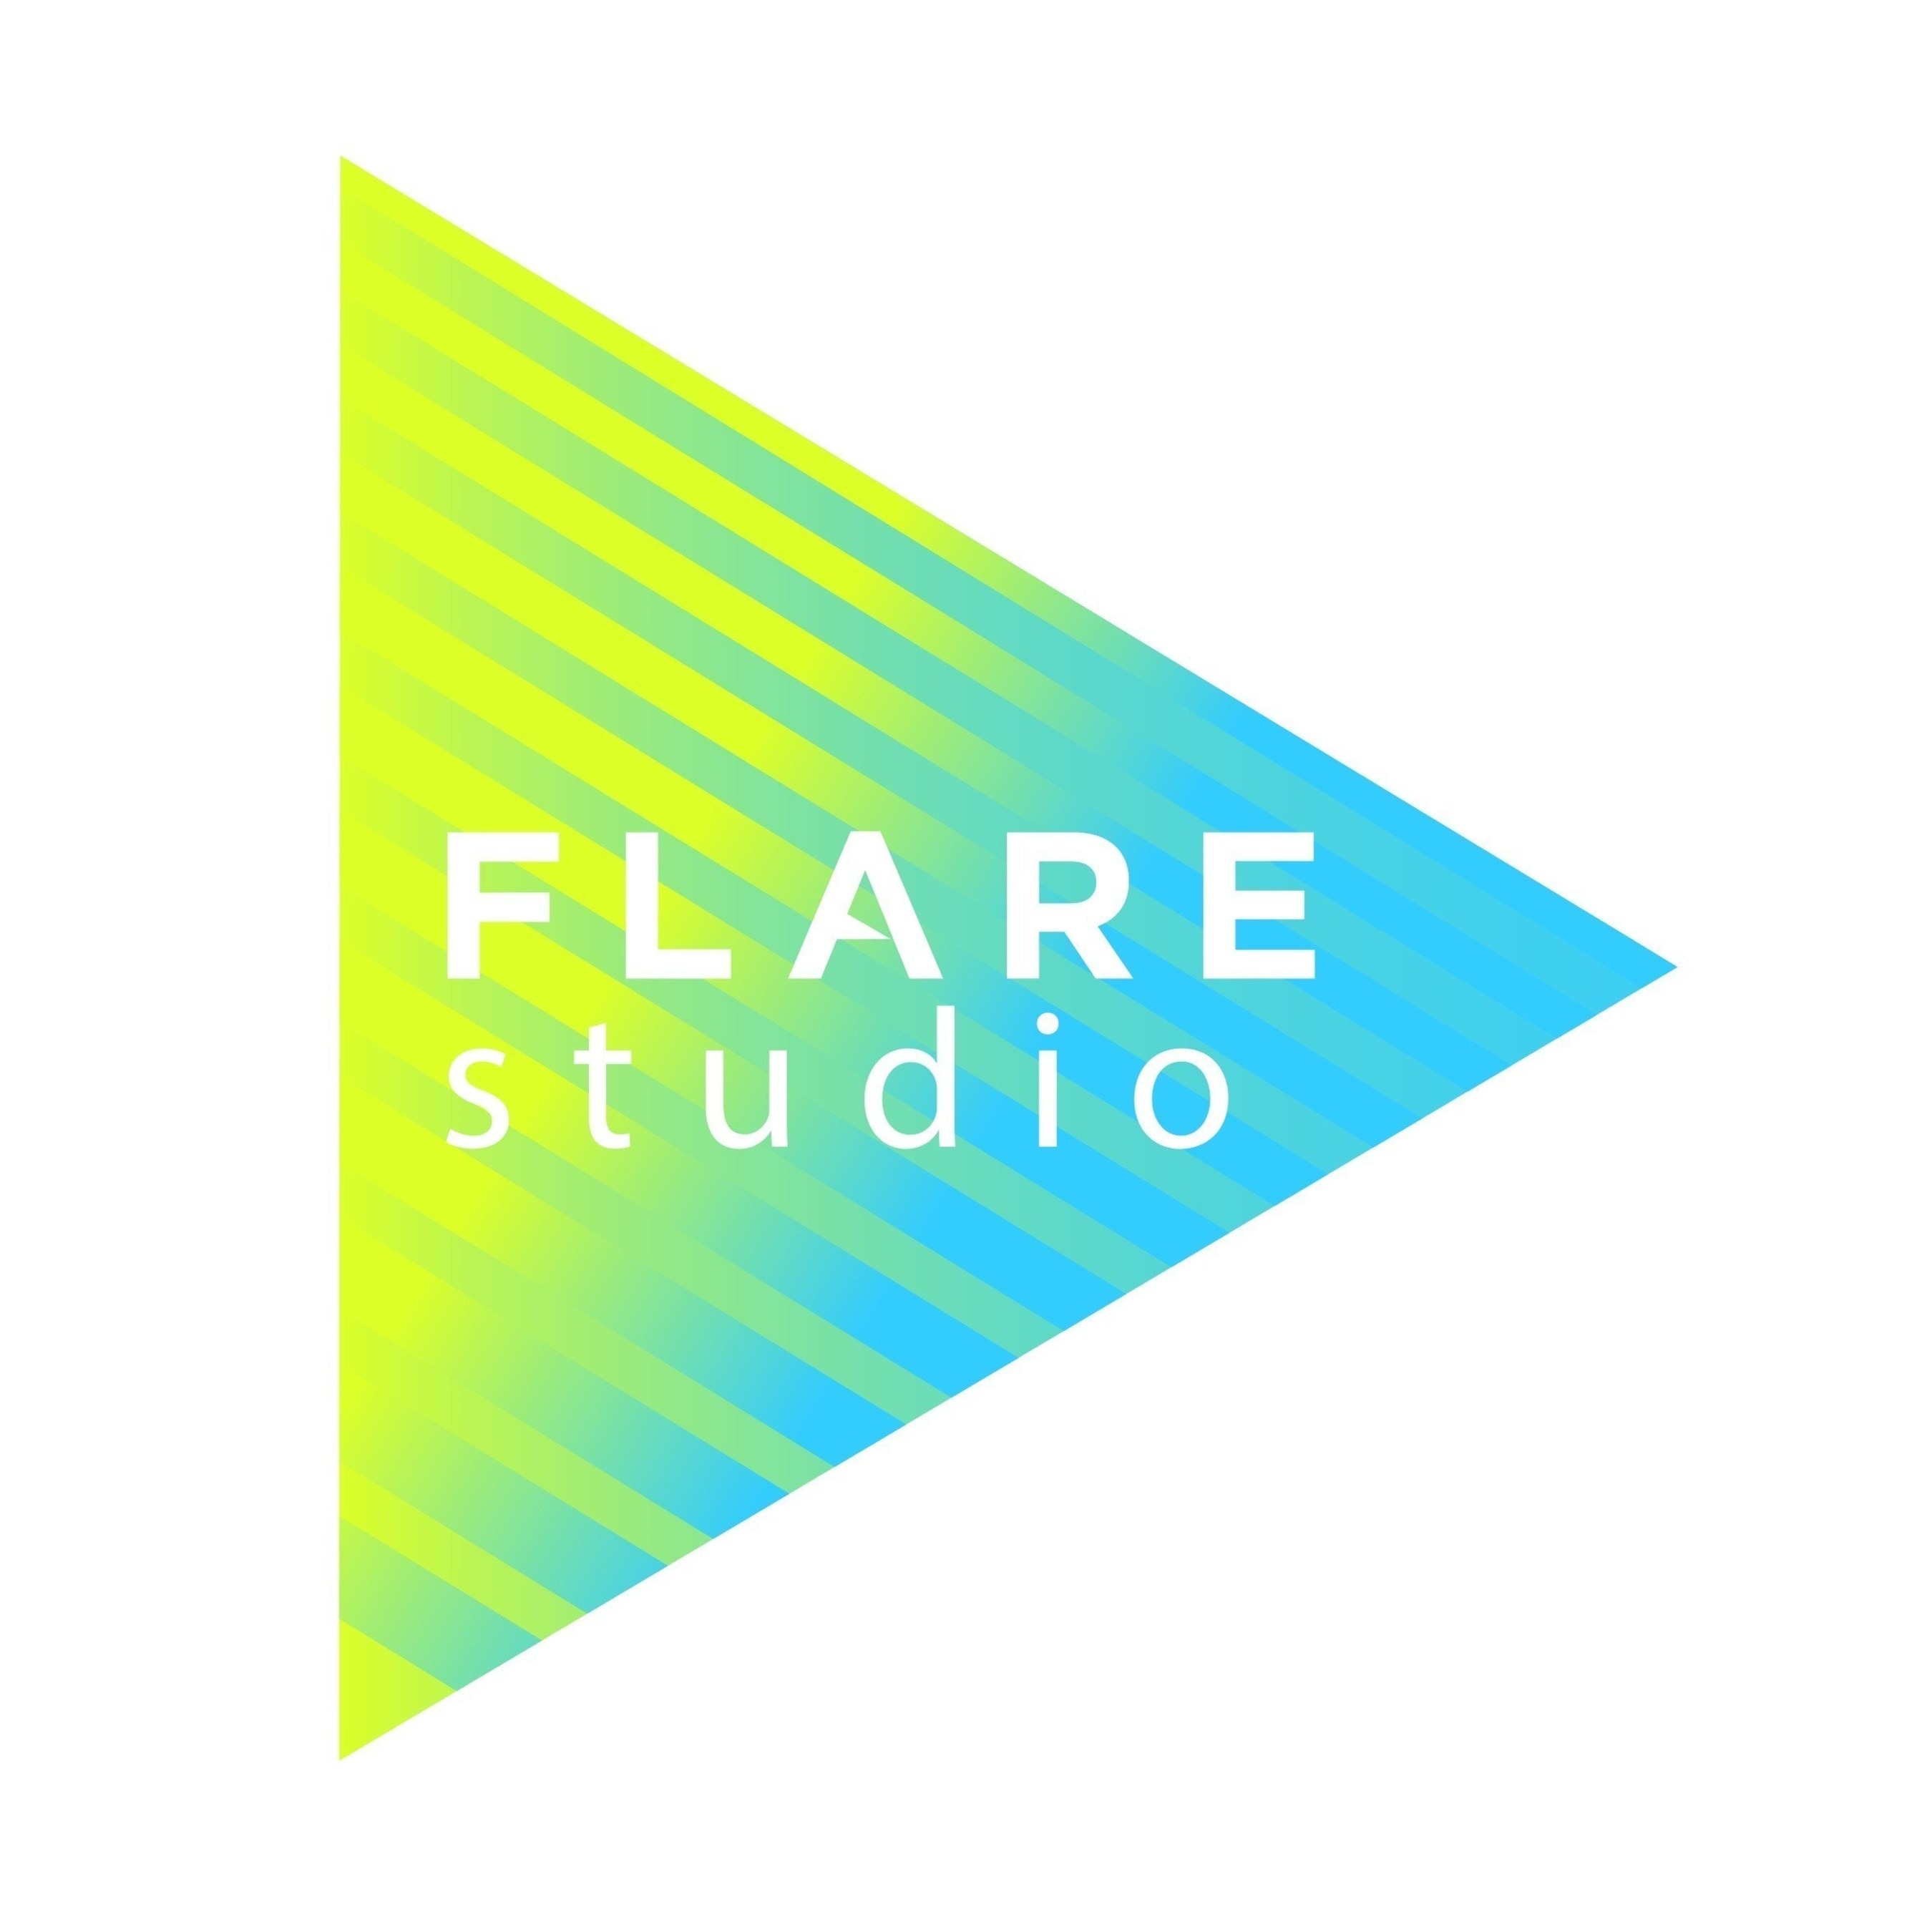
At Flare Studio, we focus on developing dynamic and user-friendly Android applications that bring innovative ideas to life. Our mission is to create high-performance mobile apps that cater to diverse user needs, from everyday utilities to advanced solutions. We prioritize functionality, design, and user experience, ensuring that our apps are not only intuitive and visually appealing but also reliable and secure. By staying on top of the latest trends in mobile technology, Flare Studio is committed to delivering exceptional products that stand out in a competitive market.

History

Preface
Flare Studio began with a vision to create exceptional mobile applications that simplify and enhance everyday tasks. Founded by a team of passionate developers and designers, we started with small-scale projects focused on utility apps. As we gained momentum, our focus expanded to include more diverse and innovative solutions, pushing the boundaries of Android development.
Over the years, we’ve grown into a reputable studio known for crafting intuitive, reliable, and secure apps. What began as a local effort has now evolved into a global initiative, where we collaborate with clients and partners from various industries to deliver mobile solutions that resonate with users worldwide. Our commitment to quality, innovation, and user satisfaction has driven us to consistently improve and expand our expertise, ensuring that Flare Studio stays at the forefront of mobile technology.

Our apps
At Flare Studio, we developed the SafeSync Contacts app, a comprehensive contact management solution designed for secure and efficient data handling. The app integrates MySQL for managing local contacts and Firebase for storing and accessing public contacts, ensuring a seamless experience for users who need both private and cloud-based contact management.

Management in action
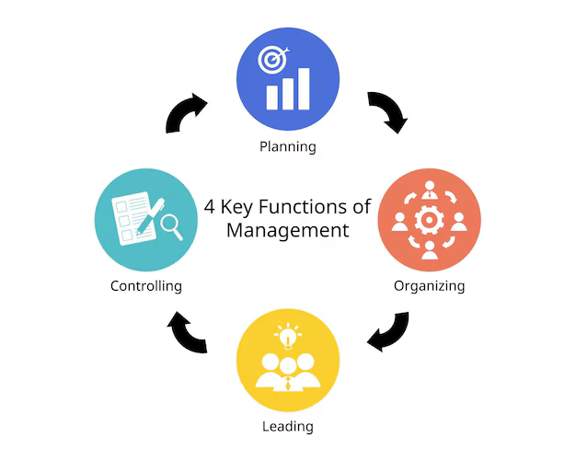
At Flare Studio, effective management is the cornerstone of our business success. We emphasize the four key functions of management—planning, organizing, leading, and controlling—to ensure our projects are delivered on time, within budget, and to the highest standards. Through careful planning, we set clear objectives, allocate resources efficiently, and establish project timelines that keep us on track. Our organizing efforts focus on structuring teams. With a strong focus on leadership, we empower our teams, while our controlling process ensures rigorous performance monitoring and quality control. This approach guarantees that our projects are not only delivered on time and within budget but also meet the highest standards of excellence.

I) Planning
At Flare Studio, planning is a critical function that enables the company to develop high-quality Android applications while staying competitive in the market. Planning at Flare Studio involves several key aspects such as goal setting, market analysis, resource allocation, and project management. Below is a detailed breakdown of the planning process with relevant data, design frameworks, and visuals.

1. Goal Setting
Planning begins with setting clear and measurable goals for the development process. These goals ensure that the team has a clear direction and can measure success.
- Short-term Goals:
  - Launch a new Android app within 3 months.
  - Achieve 95% customer satisfaction within the next product release.
  - Reduce bug reports by 15% in future app versions.
- Long-term Goals:
  - Expand into iOS development within the next 2 years.
  - Enter international markets, focusing on Europe and North America by 2025.
Types of Goal | Description | Time Frame
Short-term Goal | Launch an Android app in 3 months | 3 months
Long-term Goal | Expand into iOS development | 2 years
Long-term Goal | Target international markets | 2025

2. Market Research and Data Analysis
Flare Studio conducts detailed market research to understand industry trends, user preferences, and emerging technologies. This data-driven approach enables the company to stay ahead of the curve.
Metric | Value
Global Android Market | 70% of global mobile OS market
Primary User Demographic | 18-34-year-olds
Emerging Tech Trends | AR, AI, and ML integration

3. Resource Allocation
Effective resource allocation is key to successful project planning at Flare Studio. Resources include skilled personnel, financial budgets, and the right development tools.
Project | Resource Allocation | Budget %
Project A | Android Development Team | 25%
Project B | AR and AI Integration Team | 40%
Project C | Quality Assurance | 35%

4. Project Planning and Timeline
Once goals are set and resources are allocated, Flare Studio creates a detailed project timeline to ensure the on-time delivery of apps.
Phases of Development:
  - Research & Ideation: 2 weeks
  - Design & Prototyping: 3 weeks
  - Development: 6 weeks
  - Testing & Debugging: 3 weeks
  - Launch & Feedback: 2 weeks
Project Timeline Gantt Chart:
Phase | Duration | Start Date | End Date
Research & Ideation | 2 weeks | Oct 1 | Oct 14
Design & Prototyping | 3 weeks | Oct 15 | Nov 5
Development | 6 weeks | Nov 6 | Dec 17
Testing & Debugging | 3 weeks | Dec 18 | Jan 8
Launch & Feedback | 2 weeks | Jan 9 | Jan 23

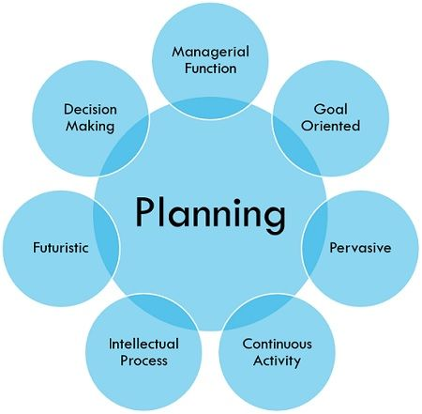
5. Design Framework for Planning
Flare Studio uses a Product Development Cycle to streamline its app development process. The framework ensures that each phase of development is well-planned, monitored, and reviewed.

Visual Design Flowchart:
- Ideation → 2. Wireframe Design → 3. Prototype Creation → 4. User Testing → 5. App Development → 6. Quality Assurance (QA) → 7. Launch & Feedback

6. Risk Management and Contingency Planning
Planning also involves anticipating risks and preparing contingency plans to mitigate issues such as development delays, technical failures, or market changes.
- Identified Risks:
  - Development delays due to lack of resources.
  - Technology adoption challenges with AI and AR.
  - Performance and cross-functional compatibility checking process.
- Contingency Plans:
  - Increase temporary staffing during critical project phases.
  - Utilize outsourced development teams in case of high workload.

II) Organizing
Once the plan is in place, organizing focuses on structuring the team and resources to implement it. At Flare Studio, this includes:

1. Defining Roles and Responsibilities
A clear definition of roles and responsibilities is essential to ensure that everyone knows their duties, their authority, and whom they collaborate with. At Flare Studio, we carefully match team members' skills and expertise to specific tasks:
- Developers: Focus on coding, debugging, and integrating features. They are organized into specialized teams like front-end, back-end, and full-stack, depending on project needs.
- Designers: Handle the user interface (UI) and user experience (UX) aspects of our apps, ensuring that the products are visually appealing, intuitive, and user-friendly.
- Project Managers: Oversee the progress of projects, ensuring that timelines are adhered to, resources are efficiently allocated, and milestones are met. They also serve as the point of communication between teams and stakeholders.
- Quality Assurance (QA): QA testers are responsible for ensuring that our apps function correctly by testing various features, finding bugs, and providing feedback to developers.
- Marketing and Sales: Work on promoting the app, managing customer relationships, and launching effective campaigns to maximize reach and revenue.

2. Task Structuring and Workflows
To maintain efficiency, tasks must be well-structured and workflows organized to ensure a smooth development process. This often involves breaking larger goals into smaller, manageable tasks. We achieve this by:
- Project breakdown: Each project is divided into key phases like planning, design, development, testing, and deployment. Each phase has specific tasks and deliverables.
- Task dependencies: Understanding and managing task dependencies is critical. For instance, designers need to complete UI mockups before developers can start coding the front-end, and the app must be developed before QA can begin testing.
- Agile Methodology: We often use Agile project management, which includes dividing projects into sprints—short, time-boxed periods where a specific set of tasks is completed. This structure allows for flexibility and continuous improvement based on feedback.
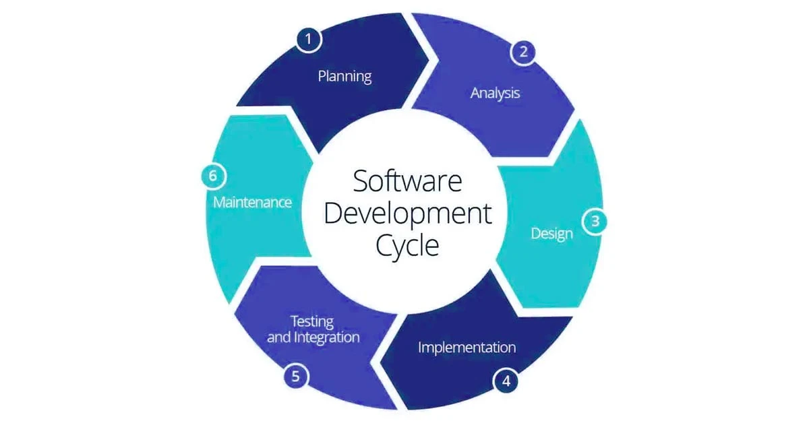
Our workflows are mapped using tools like Jira or Trello, where tasks are tracked, assigned to individuals, and moved through stages from "To Do" to "Done," ensuring everyone has visibility into project progress.

3. Coordination Across Teams
At Flare Studio, organizing also means ensuring smooth coordination between different departments. This is especially important as we often have different teams working on the same project simultaneously. Effective coordination involves:
- Cross-functional collaboration: Designers, developers, and testers need to communicate frequently to ensure the final product aligns with the original vision. Regular meetings, daily stand-ups, and progress reports help keep everyone in sync.
- Collaboration tools: We use tools like Slack, Google Workspace, and Confluence for real-time communication and documentation.

4. Resource Allocation
Effective organizing ensures that resources are allocated optimally across all projects. Resources at Flare Studio include:
- Human Resources: We ensure that developers, designers, and testers are assigned according to their strengths. For example, developers with expertise in database management might work on the backend of an app, while those skilled in UI/UX focus on front-end tasks.
- Technological Resources: From software licenses to cloud storage solutions, we make sure that teams have the tools they need, such as Android Studio, Firebase, or testing platforms, to execute their tasks efficiently.
- Financial Resources: Organizing also involves budgeting and ensuring that projects stay within financial limits.

5. Managing Multiple Projects Simultaneously
Flare Studio often handles multiple projects at once, each with different scopes, timelines, and client expectations. Organizing involves prioritizing these projects to make sure resources are appropriately divided without overloading any team. We use:
- Project prioritization: Based on deadlines, complexity, or strategic value. Projects that generate higher revenue or are close to launch may receive more resources at critical times.
- Time management: We track team capacity, ensuring no one is overloaded, and adjust timelines or add resources if needed to meet project deadlines.
Balancing resources and workflows across multiple projects helps us maintain productivity and avoid bottlenecks.

6. Building a Flexible and Adaptive Organizational Structure
At Flare Studio, organizing is not rigid. We foster an adaptable structure where teams can shift and evolve based on project requirements. For instance:
- We may reassign developers from one project to another if there’s a critical need.
- We encourage cross-training, so team members can cover different roles if necessary, which improves our flexibility.

7. Documenting Processes
Finally, organizing includes creating and maintaining clear documentation for processes, from coding standards to deployment pipelines. Documentation ensures that new team members can quickly onboard, and existing teams have a reference to maintain consistency and quality in their work.

We often work on multiple projects simultaneously, and effective organization ensures that each one receives adequate attention and resources.

III) Leading
Leadership is critical in motivating our team to achieve project goals. At Flare Studio, we promote a collaborative culture, where leaders inspire and guide teams rather than simply managing them. Our leadership practices involve:

1. Leadership Approach
At Flare Studio, leadership emphasizes collaboration, communication, and empowerment. Leaders are more than managers; they guide, inspire, and motivate teams toward achieving project and business goals.
Leadership Element | Details
Communication | - Transparent sharing of company vision and objectives.  - Regular updates on project status.
Motivation | - Recognizing and rewarding exceptional performance.  - Encouraging creativity and ownership.
Empowerment | - Delegating authority, allowing teams to make decisions.  - Providing support when facing challenges.
Mentorship | - Leaders act as mentors, providing guidance and skill development opportunities for team members.

3. Team Motivation & Culture
Flare Studio fosters a positive work environment where employees feel motivated and valued, driving higher productivity and creativity.
Motivation Factor | How It’s Implemented
Incentives | - Bonus system based on performance metrics (e.g., app launch success, feature delivery).  - Recognition in team meetings and company-wide communication.
Work-Life Balance | - Flexible working hours and remote work options to ensure employee well-being.
Team-Building | - Regular team-building events, both virtual and in-person.

4. Decision-Making
Leadership at Flare Studio encourages collective decision-making, especially when addressing project challenges.
Decision Type | How It’s Made
Product Features | - Decisions on app features involve input from developers, designers, and marketing.  - Customer feedback also shapes the final decision.
Project Prioritization | - Leadership, alongside project managers, assesses resource availability and project deadlines to prioritize tasks.
Problem-Solving | - Open forums and team brainstorming sessions help solve complex issues (e.g., bugs, UI redesigns).
Risk Management | - Leadership identifies potential risks early and devises contingency plans (e.g., Firebase scalability issues, app crashes).

5. Performance Management
Performance tracking is essential in leading teams to success. Leaders use clear performance metrics to ensure individual and team progress aligns with company goals.
Performance Metric | How It’s Measured
Project Milestones | - Progress against development schedules and deadlines.  - Meeting sprint goals in Agile.
Productivity | - Lines of code, number of resolved bugs, and feature delivery.  - Time spent on tasks versus estimated time.
App Quality | - User feedback and ratings in the Google Play Store.  - Crash-free rate and bug reports post-release.
Team Engagement | - Feedback from regular one-on-one sessions and anonymous team surveys.  - Employee retention rates and morale.

6. Conflict Resolution
Leaders are also responsible for managing and resolving conflicts within the team, ensuring a harmonious work environment.
Conflict Type | Resolution Strategy
Technical Disagreements | - Leaders mediate discussions and encourage data-driven decisions (e.g., choosing between two coding frameworks).
Interpersonal Conflicts | - Encourage open communication and finding common ground.  - One-on-one meetings to address personal grievances.
Resource Allocation Issues | - Reassess project needs and allocate additional resources if needed (e.g., adding more developers to speed up feature completion).

7. Leadership Impact
By focusing on these leadership strategies, Flare Studio ensures that teams are driven, productive, and aligned with company goals, resulting in the following:
Outcome | Impact
Improved Productivity | - Teams consistently meet or exceed project deadlines.  - Faster app feature rollouts.
High Job Satisfaction | - Employee surveys show strong satisfaction with leadership and work culture.  - Low employee turnover.
Innovation | - Empowered teams lead to more creative solutions, driving innovative apps.
Better Decision-Making | - Collective decision-making results in fewer errors and more robust app features.

IV) Controlling
The final function, controlling, involves monitoring progress and performance to ensure that goals are met. At Flare Studio, this process includes:

1. Performance Monitoring
We continuously track key metrics to measure project progress. For example, we monitor sprint completion rates using tools like Jira, keeping an eye on the percentage of tasks completed. Developers' progress is also measured by lines of code written and the number of bugs resolved, which we track via GitHub and Bugzilla. This allows us to spot any delays or blockers early and adjust team priorities accordingly.
For app performance, we rely on tools like Firebase Crashlytics and Android Profiler to monitor key indicators like crash-free sessions, app load times, and memory usage. Real-time tracking ensures we catch performance issues quickly, improving the user experience.

2. Quality Control
Flare Studio ensures high-quality app releases through a mix of automated and manual testing. During development, unit testing ensures that individual code components function correctly, while integration testing checks how different modules interact. We use tools like JUnit, Espresso, and Firebase Test Lab to automate these processes. Before release, we perform manual UI/UX testing to ensure that the interface is intuitive and works smoothly across devices.
Besides, we periodically run automated tests in order to make sure our quality passes a standard and the set of all test cases.

3. Budget Control
Staying within budget is a crucial part of controlling. We regularly track development costs, such as the hours spent by developers, software licenses, and third-party services like Firebase. By using project management software and detailed financial tracking, we ensure that resources are allocated appropriately.

4. Corrective Actions
When issues arise, whether it’s falling behind schedule, budget overruns, or quality problems, we take corrective actions to minimize impact. For example, if deadlines are missed, we might reallocate additional developers to a project or extend the sprint timeline to accommodate the work.
If quality issues are discovered during testing, we increase the frequency of code reviews or testing cycles to ensure that bugs are fixed before launch. In case of budget overruns, we might reevaluate feature priorities, cutting non-essential ones to ensure the project remains financially viable. Performance problems, such as app crashes or slow loading times, are tackled by optimizing code and reconfiguring our infrastructure for better efficiency.

5. Feedback Loops
Feedback is an integral part of the controlling process. We regularly gather feedback from clients, team members, and end-users. Client feedback helps us adjust project scope or timelines, ensuring that we meet their expectations. Internally, team members provide input during sprint retrospectives, allowing us to identify areas for improvement, such as adjusting workloads or reallocating resources.
Customer feedback, such as app store ratings and user reviews, is essential for post-launch updates. If users request features or report bugs, we prioritize those issues in future updates to enhance user satisfaction and app performance.

6. Final Evaluation
After a project is completed, we conduct a final evaluation to assess overall success. We compare the actual project timeline to the planned schedule and analyze whether we stayed within the budget. The success of the app itself is measured by user metrics like downloads, app store ratings, and revenue generated. We also gather feedback from the development team through a final retrospective, identifying lessons learned and improvements for future projects.

The controlling function is essential for Flare Studio for several reasons:
- Ensures Project Alignment with Goals: Controlling helps maintain alignment with project objectives. By monitoring performance metrics and adhering to timelines and budgets, we ensure that all team efforts contribute to the overall goals of the company and client satisfaction.
- Quality Assurance: High-quality apps are critical in the competitive Android marketplace. Through rigorous quality control processes, we minimize bugs and enhance user experience, which is crucial for positive app reviews, user retention, and brand reputation.
- Efficient Resource Management: Effective controlling allows us to allocate resources wisely. By tracking development and marketing expenses, we can avoid wasteful spending and ensure that every dollar is used efficiently, ultimately contributing to better profit margins.
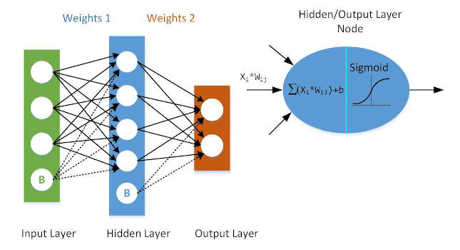
- Early Problem Identification: Regular monitoring of project metrics allows for the early detection of potential issues, such as falling behind schedule or exceeding the budget. This proactive approach enables timely corrective actions, reducing the impact of problems and keeping projects on track.
- Informed Decision-Making: Controlling provides data-driven insights that support strategic decision-making. By analyzing performance and feedback, leaders can make informed choices about resource allocation, project prioritization, and feature development, enhancing overall efficiency.
- Continuous Improvement: The feedback loops established through the controlling process facilitate continuous improvement. By evaluating project outcomes and gathering input from team members and clients, we can refine processes and practices, leading to better performance in future projects.
- Stakeholder Confidence: Demonstrating effective controlling builds trust and confidence among stakeholders, including clients, investors, and team members. When stakeholders see that projects are managed effectively and aligned with objectives, it fosters a culture of transparency and reliability.
- Adaptability to Change: The tech landscape is constantly evolving, and client needs can shift rapidly. A robust controlling function allows us to adapt quickly to changes in project requirements, market demands, or technology trends, ensuring that we remain competitive and relevant.

Conclusion
At Flare Studio, the four key functions of management—planning, organizing, leading, and controlling—are central to business success. Planning involves setting clear goals, conducting market research, and allocating resources efficiently to meet short- and long-term objectives. Organizing focuses on structuring teams, defining roles, and creating workflows that enhance cross-functional collaboration. Leading emphasizes a collaborative approach where leaders inspire, motivate, and empower teams to achieve their best while encouraging open communication and innovation. Finally, controlling ensures that projects stay on track through performance monitoring, quality control, and continuous feedback loops, allowing the studio to quickly identify and address issues, maintain high standards, and foster continuous improvement. This comprehensive management approach drives Flare Studio’s ability to deliver high-quality mobile applications and maintain competitive advantage in the market.

